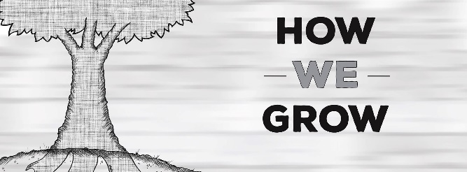

Good Fruit
Matthew 7:15-23 (Pg. , Galatians 5:19-23

How do I know if I’m actually growing?

Jesus said, “Look at the fruit.”
Good tree; good fruit
Bad tree; bad fruit.
What kind of fruit are you producing?

Four Tools for Future Fruitfulness:
- Know your strengths- DNA Seminar
- Tell your story- Glow Seminar
- Share your resources- Financial Stewardship
- Go to the world- Cross-Cultural Experience

